# **Name: Abdurrahman Qureshi**

# **Roll No: 242466**

Practical No: 2

Date Of Performance: 15/07/2025

Aim: To understand and demonstrate the creation, connection, and basic usage of a Windows EC2 instance in AWS, followed by proper termination.

1. What is IaaS?
2. What is MobaXterm? Is MobaXterm the same as PuTTY?
3. Launch one instance of AWS EC2. This instance should be Ubuntu [ Free Tier Available]. Get connected to instances using MobaXterm Client software. Explain each step of EC2 creation and launching with the help of screenshots.

Check the IP address of your EC2 ubuntu server.

[Terminate the instances after performing the practical]

Ans 1:

**IaaS (Infrastructure as a Service)** is a cloud computing model where a provider delivers virtualized computing resources over the internet. Instead of purchasing physical servers, businesses rent infrastructure components like virtual machines, storage, networks, and operating systems on a pay-as-you-go basis.

**Key Features of IaaS:**

* **Scalability:** Easily scale resources up or down based on demand.
* **Cost-Efficiency:** No need to invest in physical hardware.
* **Self-Service:** Users can provision and manage resources via a dashboard or API.
* **Flexibility:** Supports various operating systems and applications.

**Examples of IaaS Providers:**

* **Amazon Web Services (AWS) EC2**
* **Microsoft Azure Virtual Machines**
* **Google Cloud Compute Engine**
* **IBM Cloud**

Ans 2:

**MobaXterm** is an advanced terminal tool for Windows that provides remote access (SSH, RDP, VNC, etc.), X11 forwarding, and built-in Unix/Linux commands (via Cygwin).

It also includes features like:

* Multiple tabs & split-screen
* Built-in SFTP file transfer
* Network tools (ping, traceroute, etc.)
* Scripting support

|  |  |  |
| --- | --- | --- |
| Feature | MobaXterm | PuTTY |
| SSH Client | Yes | Yes |
| Multiple Tabs | Supports multi-tabbed sessions | No (Single session only) |
| X11 Forwarding | Built-in (No extra setup) | Requires Xming/third-party tool |
| SFTP/File Transfer | Built-in file browser (drag & drop) | Requires WinSCP/separate tool |
| RDP/VNC Support | Yes (Integrated) | No |
| Unix Commands (Bash) | Includes Cygwin-based tools | No |
| Portable Version | Yes (No installation needed) | Yes |
| Session Management | Saves sessions & credentials | Basic session saving |
| Network Tools | Ping, traceroute, etc. built-in | No |
| Scripting Support | Yes (Bash/Python/Perl) | Limited (Basic macro support) |
| User Interface | GUI-based with advanced options | Minimalist (Text-only) |

Ans 3:

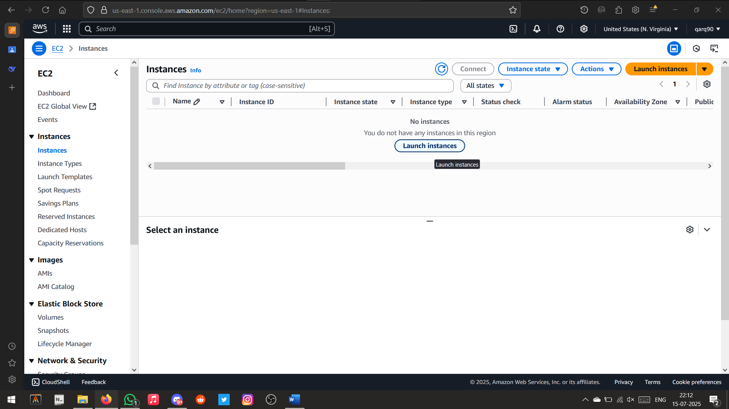

Launching/Creating and EC2 Instance

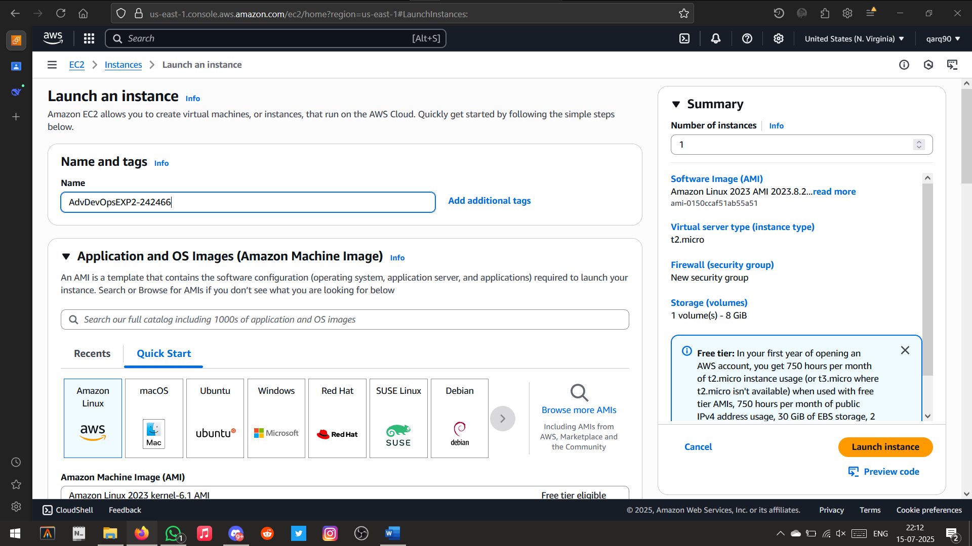

Setting the name and Operating System

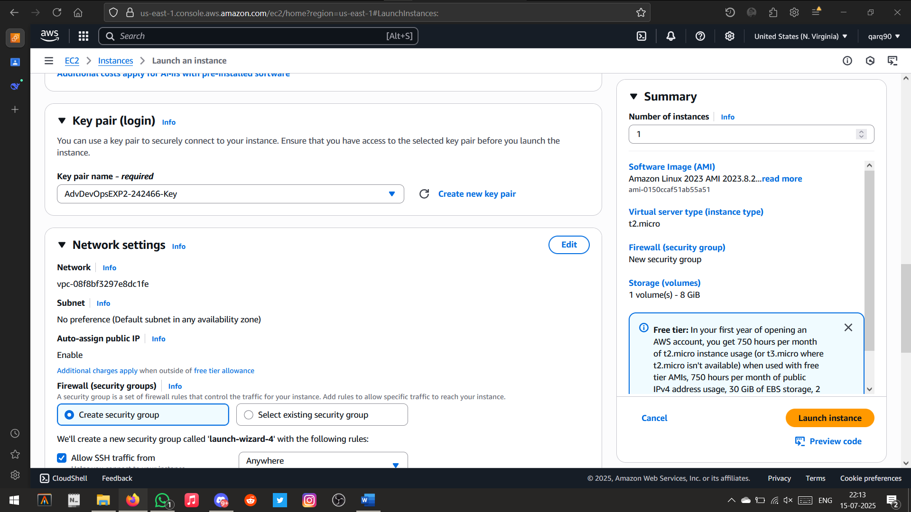

Creating Key Pair

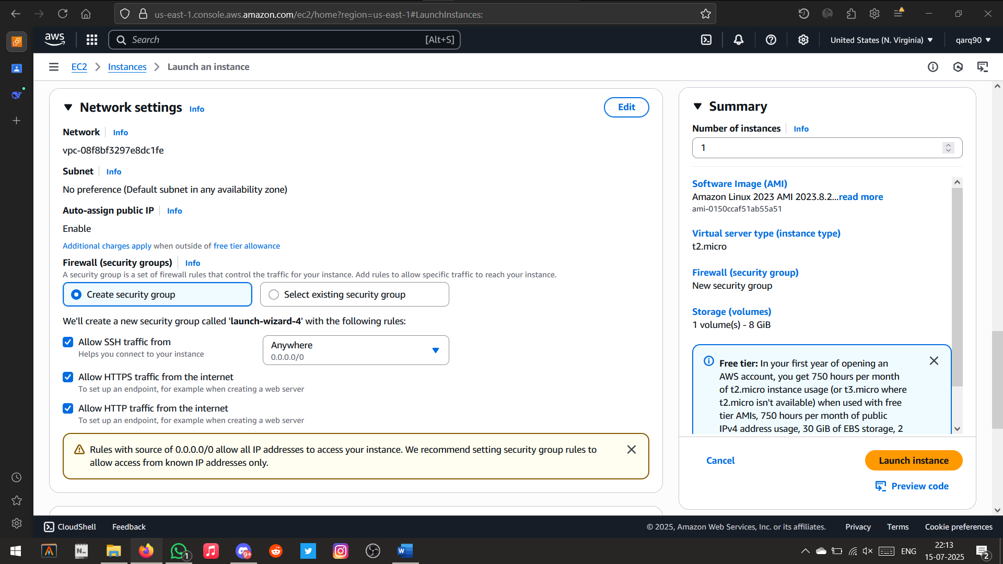

Setting up the network settings

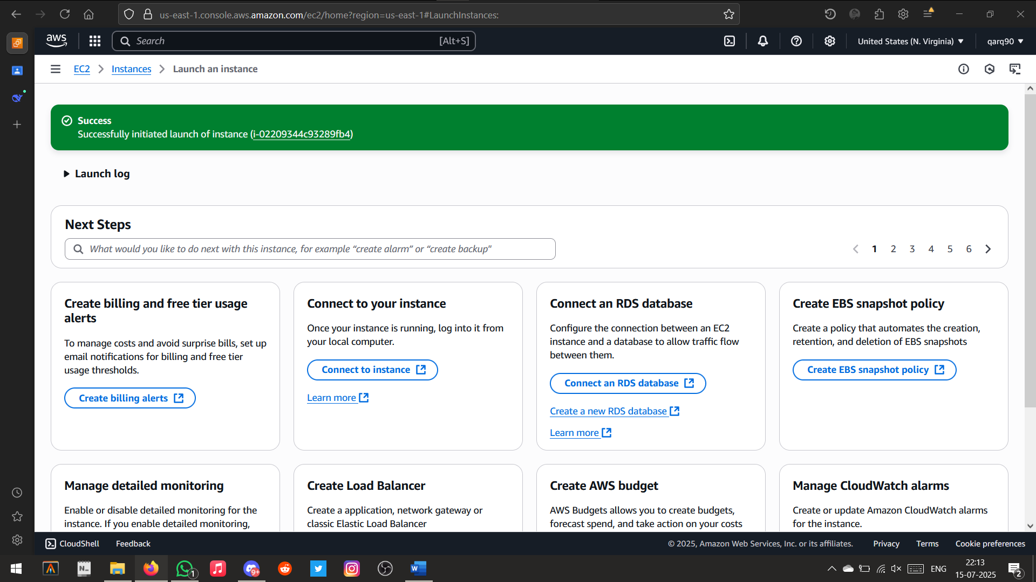

Instance Created Successfully

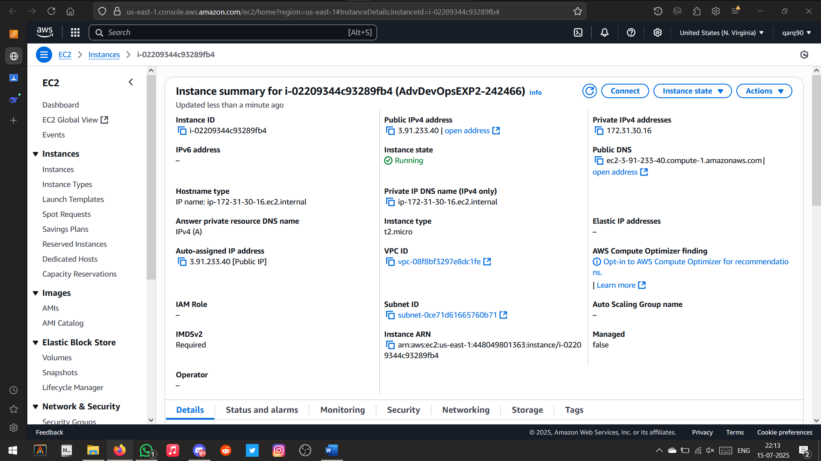

Instance Details

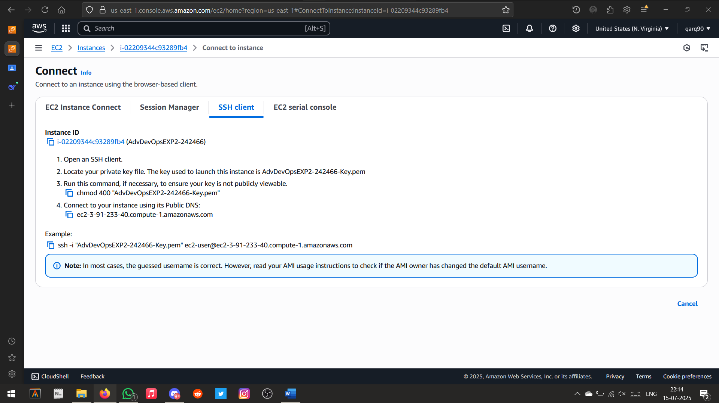

Connecting to the Instance via SSH Client

User: ec2-user

Public DNS: ec2-3-91-233-40.compute-1.amazonaws.com

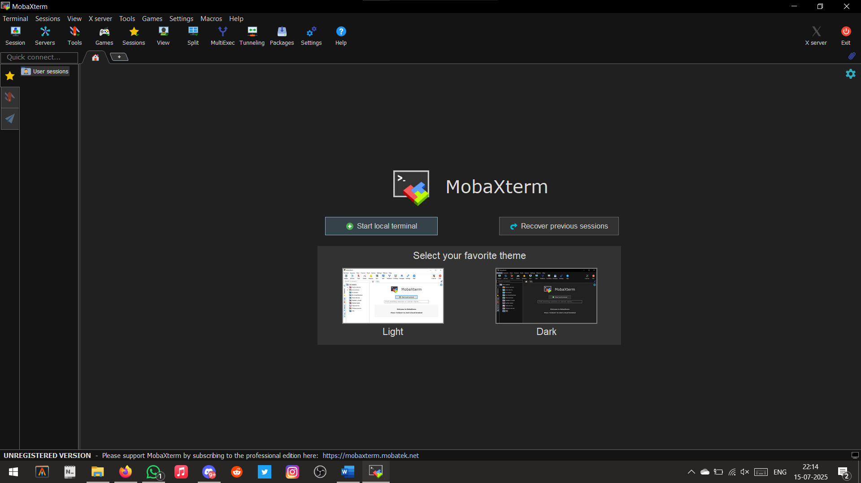

Launching MobaXTerm

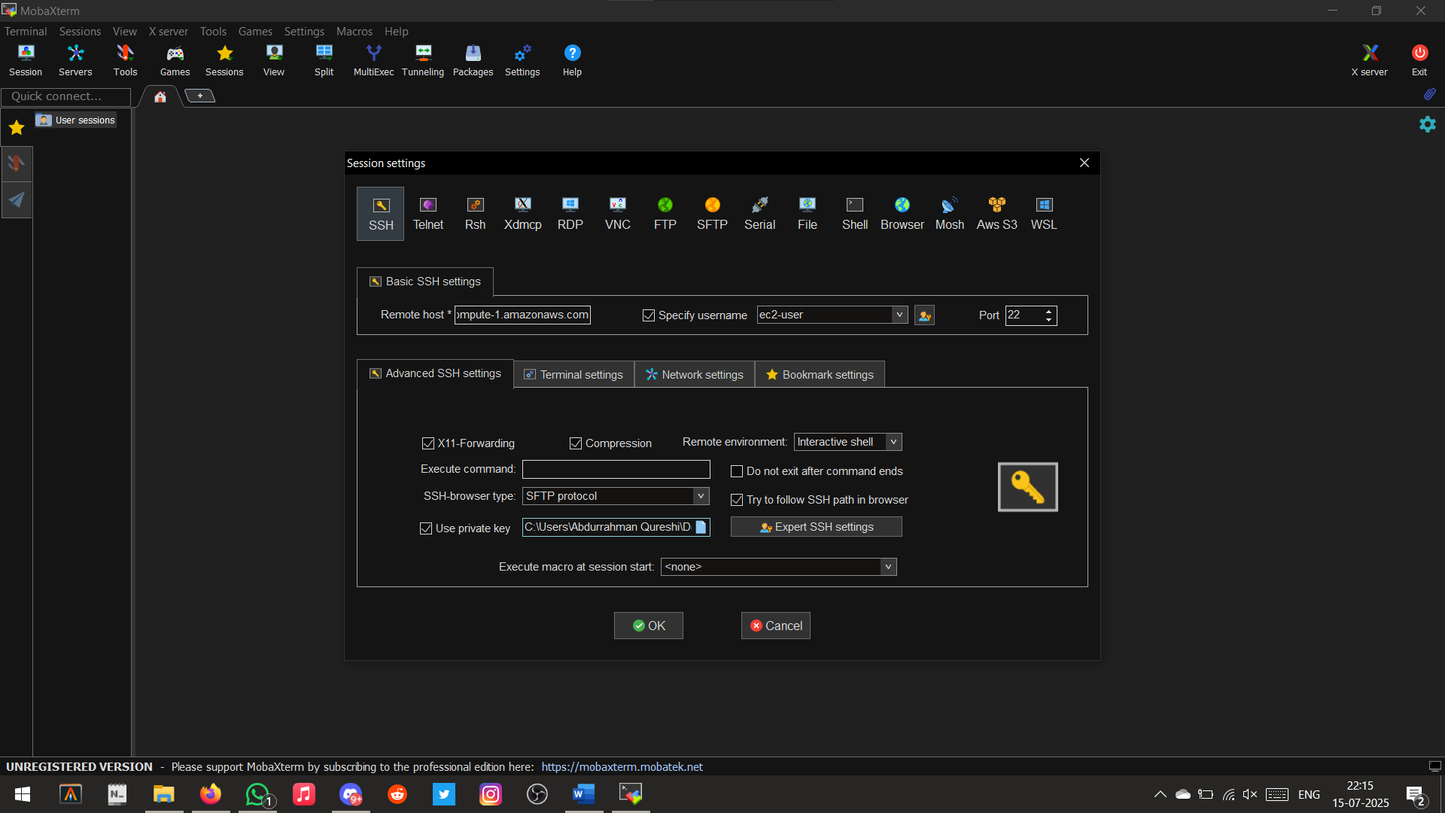

Configuring and Connecting to EC2 Instance

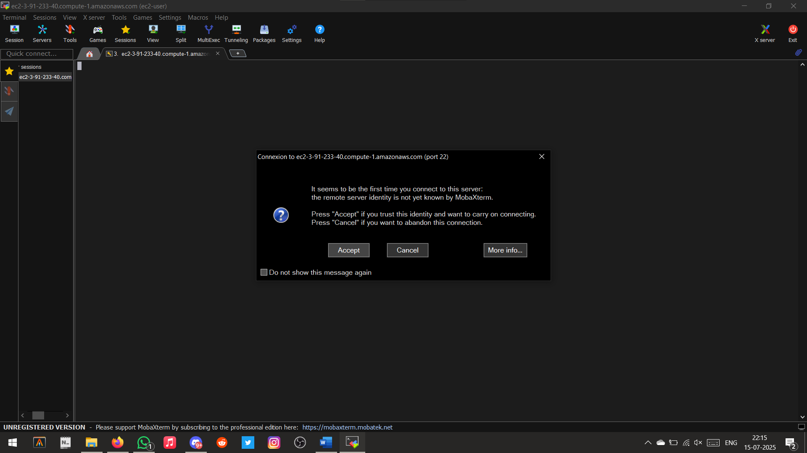

Connection Successful

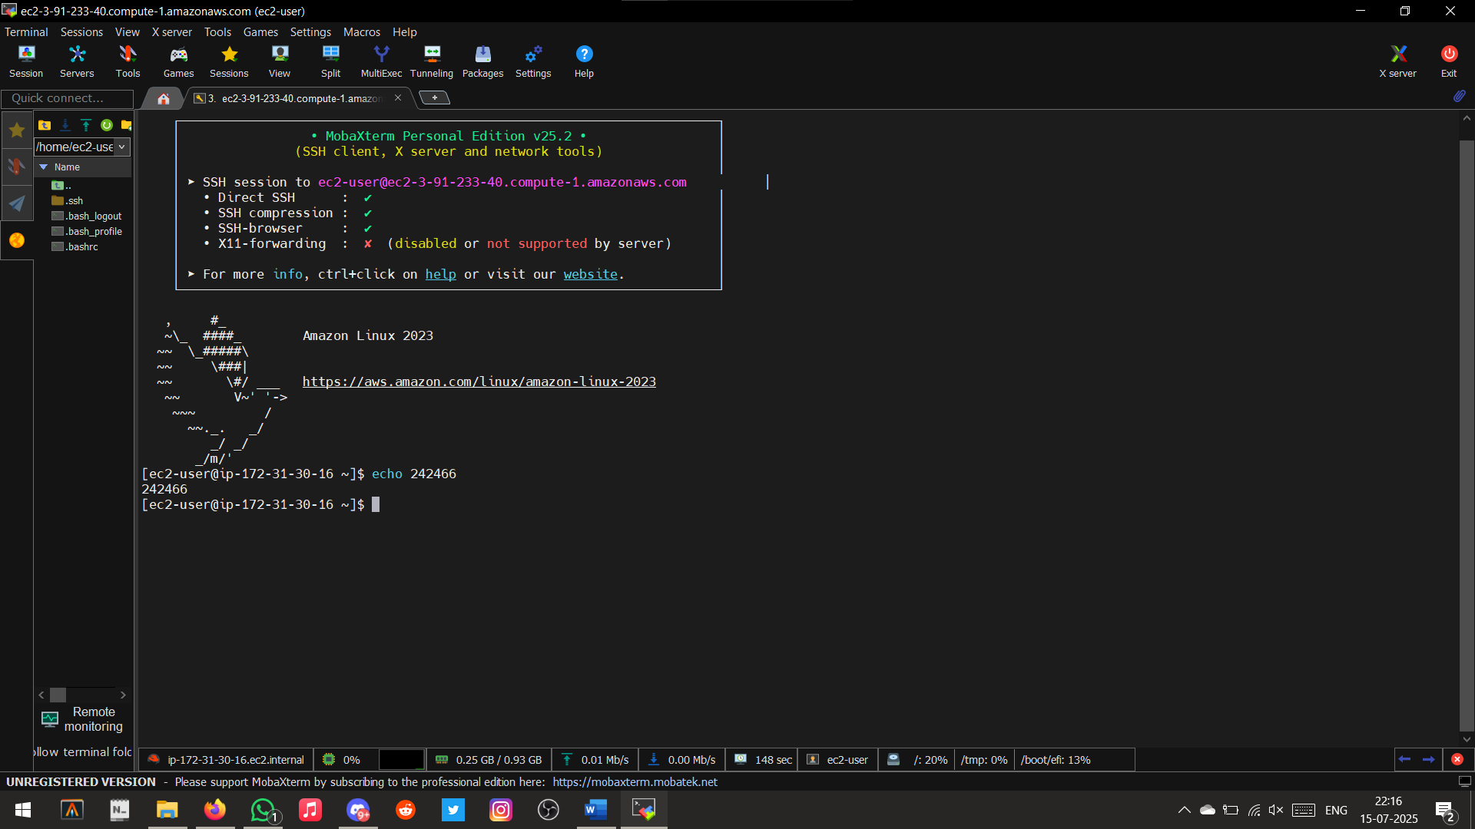

Running Test Commands

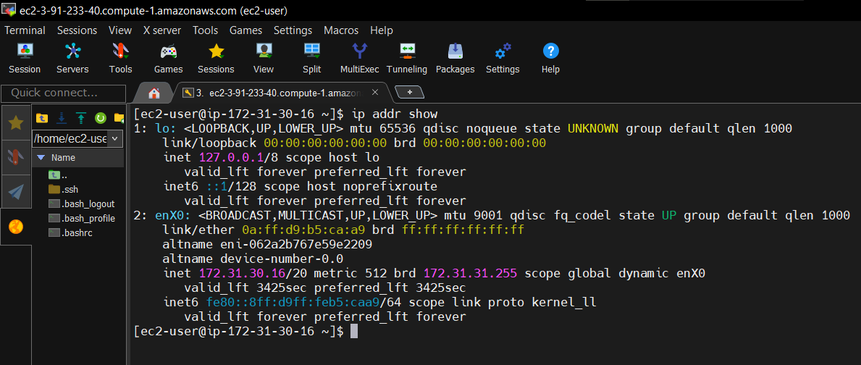

Checking IP address